# TITLE PAGE

**DESIGN AND IMPLEMENTATION OF MEN SALOON MANAGEMENT AND BOOKING SYSTEM**

**BY**

**NAFRUONO GEOFFREY** JONAH

**ST/CS/ND/19/192**

**DEPARTMENT OF COMPUTER SCIENCE,**

**SCHOOL OF SCIENCE AND TECHNOLOGY,**

**FEDERAL POLYTECHNIC, MUBI, ADAMAWA STATE.**

**IN PARTIAL FULFILLMENT OF THE REQUIREMENT FOR THE AWARD OF NATIONAL DIPLOMA (ND) IN COMPUTER SCIENCE.**

**JANUARY, 2022**

# DECLARATION

I hereby declare that the work in this project titled **“Design and Implementation of Men Saloon Management and Booking system”** was performed by me under the supervision of Mrs. Aaron Catherine. The information derived from literatures has been duly acknowledged in the text and a list of references provided. The work embodied in this project is original and had not been submitted in part or in full for any other diploma or certificate of this or any other institution.

NAFRUONO GEOFFREY JONAH ________________ _______________

(ST/CS/ND/19/192) Signature Date

# CERTIFICATION

This project work titled **“Design and Implementation of Men Saloon Management and Booking system”** meets the regulations governing the award of National Diploma (ND) in Computer Science, Federal Polytechnic Mubi, Adamawa State

Mr. Aaron Catherine __________________

(Project Supervisor) Sign/Date

Mallam Adamu Garba Mubi __________________

(Head of Department) Sign/Date

_______________________ _________________

(External Examiner) Sign/Date

# DEDICATION

We dedicate this project work to Almighty God for granting me the ability to accomplish this work successfully.

# ACKNOWLEDGEMENTS

I want to acknowledge Almighty God for his infinite mercy and protection throughout our academic activities. And for the understanding in achieving our academic success.

I also acknowledge the Head of Department Computer Science Mallam Adamu Garba Mubi for his moral encouragement throughout our period of study.

I also recognize our Supervisor Mrs. Aaron Catherine who took time, despite her busy schedule to directed and guided us throughout this research work.

I also acknowledge all Staff of Computer Science Department for their support and encouragement and the knowledge they’ve impacted on us throughout our studies.

I also want to appreciate our parents for their love and care and for giving us the opportunity to be trained and achieve our dreams.

Finally, I appreciate the efforts of our Uncles and aunties, for their encouragement and support throughout the course of our study and also our friends and relatives, course mates and all well-wishers. I love you all, may the Almighty God bless you abundantly, Amen.

TABLE OF CONTENTS

TITLE PAGE i

DECLARATION ii

CERTIFICATION iii

DEDICATION iv

ACKNOWLEDGEMENTS v

LIST OF FIGURES vii

LIST OF TABLES viii

ABSTRACT ix

CHAPTER ONE 1

INTRODUCTION 1

1.1 Background to the study 1

1.2 Problem statement 3

1.3 Aim and Objectives 3

**1.5** **Scope of the Study** 4

1.6 Definition of Operational Terms 4

2.2 Modern Information System Design 6

2.3 Information System 6

2.4 Computer-Supported Cooperative Work 7

2.5 Moving online 7

CHAPTER THREE 9

SYSTEM ANALYSIS AND DESIGN 9

3.1 Introduction 9

3.2 Disadvantages of the existing system 9

3.3 Advantages of the proposed system 9

3.4 The proposed method 9

3.5 Methods of data collection 9

3.6 System design 10

# LIST OF FIGURES

Figure 3.1: Use Case Diagram - - - - - - 24

Figure 3.1: Admin Login - - - - - - - 25

Figure 3.2: Search Project - - - - - - - 26

Figure 3.3: Upload Project - - - - - - - 26

Figure 4.1: Welcome interface - - - - - - 28

Figure 4.3: Login interface - - - - - - - 28

Figure 4.4: Add User interface - - - - - - 29

Figure 4.5: Dashboard interface - - - - - - 29

Figure 4.6: Add Project interface - - - - - - 30

# LIST OF TABLES

Table 3.1: Admin Table - - - - - - - 25

Table 3.2: Project Table - - - - - - - 25

# ****ABSTRACT****

*This project titled “Design and implementation of Men Saloon Management and Booking system” is aimed at developing a module that would handle registration customers and services of the salon easily manage the data and also to create a system that would allow users make online booking from the comfort of their homes. The methodology involves using PHP, Apache and MySQL while front-end is designed with PHP, the back-end is managed with MySQL. The system is more secured and user-friendly. The results where gotten from tested data and the system found to be functioning as expected. The researcher also makes recommendation that the system be implemented by most saloons so as to put the system to use for effective utilization of the system.*

# 

# CHAPTER ONE

# INTRODUCTION

## 1.1 Background to the study

The 21st century is said to be century of inventions, century of development, century of globalization because no one can end up the day without using any kind of embedded system products. It makes human life very smarter and to feel comfortable. Being a salon client today is inconvenient. The customer has to remember that the customer need to make an appointment, then hope he or she remember during business hours, and finally scramble to find the phone number and take time out of his or her busy day to make the call. And never mind finding user reviews of local salons, tracking those down somewhere on the web is a headache that most don’t even attempt. This is the experience of countless salon-visitors every day. As traditional methods of hair salon are inefficient, therefore proposed system is known as “smart hair salon management system” is considered here. The proposed system is based on embedded system. In this system, first the customer messages or call to the salon then worker at the salon accepts this message or call. Worker first calculates how many customers are waiting as well as predefined time for particular activity to give reply of that message. When the customer comes in particular given time, worker give service to it according to their demand. Similarly, the process is continues and queue is formed based on the functions (Yonan, 2019).

Salon Management System (SMS) is an online system that offers beauty services and treatment. This Salon offers beauty and service included massage, make-up, sauna and hair treatment. Spa Beauty Management System is an online system that is basically specializes on managing the spa beauty management. It is an online system that the staff and management can manage management works. As a source of information, records can be seen as a strategic resource for hair salons. According to Kasim (2011), affirm that information can be viewed from the resource-based view of the firm in accordance with strategic management theory. Basically, this perspective suggests that resources are vital for organisational success. As businesses utilise resources as inputs, they transform them into outputs for sale to make profits. Thus, without resources, no organisation can survive. Therefore, these resources must be jealously protected and properly managed. The implication for hair salons is that information in the form of business records need to be properly managed if they in order to survive in their fiercely competitive business environment. This means that good records management can be used by hair salons as a strategic resource to improve business performance (Hint, Ireland & Hoskisson, 2011).

The main objective of any business is to make profit through its product or service. For the businesses to succeed they need to make use of the assets at their disposal. Records are one of the assets that they need to manage in order to be profitable and remain in business. Records management should be a serious business function of every business including smaller ones like hair salons as it can make or break profitability. According to Tushabomwe-Kazooba (2016) specifically warns that poor record keeping is a major cause of small business failure. This author goes on to point out that because most small businesses do not keep proper records, they end up losing track of their transactions and cannot account for their expenses and their profits with the end result being business closure. But business should not just keep records for the sake of keeping it. Rather, records should be kept for future reference in decision making. Records contain vital information such as evidence of business transactions (Kasim, 2011). Transaction records can provide a window into the future for hair salons as past and current transactions can provide trends that they can use to project their future level of performance. According to Kemoni and Ngulube (2018) and Makhura (2015) agree that good records management is vital to a business because it facilitates free flow of information that ensures timely and rapid availability of information when most needed for decision making. Some scenarios where authentic and reliable information is needed include litigation and tax assessment Smith (2017).

According to Florida (2010), businesses need to manage records in order to meet legal, fiscal and administrative requirements. In the case of hair salons, records of chemicals used on hair could become very handy during damage claims while settling tax issues requires availability of appropriate financial records. There are a number of good reasons for having good records management practice in place. According to Hampton (2012), reasons for records management practices include: To control the creation and growth of records, reduce operating costs, improve efficiency and productivity, ensure regulatory compliance, minimize litigation risks, safeguard vital information, support better management decision making, preserve the corporate memory and foster professionalism in running the business All of the above are very relevant to hair salons. For example, proper records management will enable hair salons keep track of operating costs so that where necessary, costs reduction can be done based on relevant information. Similarly, good management will enable salons defend them themselves against lawsuits by producing records in defence. This means that hair salons can save time and money during litigation by falling on their records. Proper record management may prevent or minimize the risk of losses in court proceedings. The aforementioned discussion shows how important records and the good record keeping can be to a business such as hair salons (Sampson, 2012).

## 1.2 Problem statement

1. The traditional system of hair salon was manual and insecure because there was no any counting system of customers coming in the salon which creates sometimes major issues. The customer as well as the owner faces the problems.
2. These early systems are dependent on paper-pencil systems for billing purpose that means the records of bills of customer and the workers working in their salon are in written form. The records may get wrong due to anyone’s mistake.
3. There is difficulty in maintaining records of all these tasks manually. Hence, proposed system is the best solution of avoiding all these problems.

## 1.3 Aim and Objectives

The aim of this research project is to design and implement a Saloon Management and Booking system. The specific objectives of this project are:

1. To develop a module that would handle registration customers and services of the salon easily manage the data.
2. To computerized the management that help the staff improving the management of the spa beauty system.
3. Registered customer with username and unique password can do appointment for treatment and services via online.
4. To develop online system that includes simple inventory.

**1.4 Significance of the Study**

Being a salon client today is inconvenient. You have to remember that you need to make an appointment, then hope you remembered during business hours, and finally scramble to find the phone number and take time out of your busy day to make the call. And never mind finding user reviews of local salons and stylists; tracking those down somewhere on the web is a headache that most don’t even attempt. This is the experience of countless salon-goers every day, even as we move well into the twenty-first century. There is a strong, well-articulated need for a “one-stop-shop” online hub that connects clients to salons, putting all the information users need in one convenient place, on demand. Equally surprising, many salons today are still using paper and pencil systems to schedule appointments and manage customers. These systems are grossly inefficient at sharing and syncing information, and are prone to costly human error. The Saloon Management information and Booking System promises to end the dependence on paper-pencil systems, and put salons in control with an easy to use interface. The Saloon Management information and Booking System will be more than just an online scheduler; it will be a salon management tool that will allow salons to manage stylists and services, promote sales to customers, and track customer satisfaction.

**1.5 Scope of the Study**

The proposed system is targeted for the effective and easy use by both users and Hair Saloon Management to enable them track and keep records of customers for future purposes. The system will include Registration of customers, Booking and Appointment and querying of the database for the necessary information for administrative purposes.

## 1.6 Definition of Operational Terms

**Collaboration Tools:** Include e-mail, threaded discussions, chat, and bulletin board software that offer a whole range of ways to communicate and share information (Boye, 2015).

**E-portal:** Rao (2013), defined an enterprise portal is a web interface for users of enterprise applications. Enterprise portals provide access to enterprise information such as corporate database, application including web applications.

**Internet Tools:** Site search and navigation tools to provide users with easy access to information. Examples are calendars and planners to allow users to input and share events, as well as Web site and content builders, offering them the ability to create and have customized content being made available according to individual profiles (Reus, 2013).

**PHP**: Normally used for increased functionality on a website or to work with a database. It works in conjunction with html and html variants and allows for functions to be run from the server rather than the visitor’s browser (Brayand, 2014).

**Portal**: A portal is a presentation layer which aggregates, integrates, personalizes and presents information, transactions and applications to the user according to their role and preferences (Brayand, 2014).

**Web Portals:** According to Babie (2014), a web system that provides the functions and features to authenticate and identify the users and provide them with easy intuitive personalized and user-customizable web-interface for facilitating access to information and services that are of primary relevance and interest to the users.

**CHAPTER TWO**

**LITERATURE REVIEW**

**2.1 Introduction**

This chapter examines in detail, the history and developments of Saloon management system and, previous research work on this subject, the characteristics, models, architectures and limitations as pointed out by various scholars and researchers. This will provide the ground work for figuring out an efficient way to implement an Online Saloon Management and booking system.

## 2.2 Modern Information System Design

A growing amount of interdisciplinary work explores the number of goals: answering how the activities of complex systems can be coordinated (Malone & Crowston, 2014). Some work focused on coordination in parallel and distributed computer systems while others on coordination in human systems (Malone & Crowston, 2014). However, the common theme is that the targeted complex systems usually include both people and computers; our project shares the same characteristic.

In modern IS design, some inter disciplinary areas enlighten on how to design Information System that is robust, reliable and cost – effective. Below are some of these inter-disciplinary fields and recent findings about them which will help us in laying down the theory background of our work.

In most of the papers reviewed above they described in detail how they designed and implemented there IS, none of them discovered and used the latest discovery of Information System by either by selecting Design Science or Behavioral Science (March & Smith, 2015).

## 2.3 Information System

According to Hevner (2014), Information Systems (IS) are “implemented within an organization for the purpose of improving the effectiveness and efficiency of that organization”. Two paradigms that characterize much of the research in the IS discipline are behavioral science and design science. The behavioral science paradigm seeks to develop and verify theories that explain or predict human or organizational behavior. The design science paradigm seeks to extend the boundaries of human and organizational capabilities by creating new and innovative artefacts.

These two paradigms are complementary but distinct (March & Smith, 2015). The behavioral science paradigm has its root in natural science research methods. It seeks to develop and justify theories that explain or predict organizational and human phenomena (Hevner, 2014). The design science paradigm has its roots in engineering and the science of the artificial (Simon, 2016). It is fundamentally a problem-solving paradigm and seeks to create innovations that define the ideas, practices, technical capabilities, and products through which the analysis, design, implementation, management, and use of information systems can be effectively and efficiently accomplished (Denning, 2017).

Our work obviously falls in the realm of the design science due to the problem-solving nature of the work. As the IS literature recognizes, while the importance of design is well recognized, designing a useful system is complex. We built on the work of the design science paradigm and followed the literature suggested guidelines in (Hevner, 2014).

## 2.4 Computer-Supported Cooperative Work

Recently, a great deal of interest has been placed on designing computer tools to help people work together more effectively. This new field designs systems called Computer-Supported Cooperative Work (CSCW) (Computer Supported Cooperative Work) or groupware. According to Ellis (2011), “the work in CSCW usually looks at how groups work and seeks to discover how technology (especially computers) can assist them.” Groupware is the technology used to support collaborative work. According to Ellis (2011), groupware consists of “computer-based systems that support groups of people engaged in a common task (or goal) and that provide an interface to a shared environment.” CSCW stresses the outcome or product while groupware is the enabling technology.

### 2.5 Moving online

According to James (2012), we're seeing a trend in saloon shop startups toward a greater integration of [technology](http://www.gaebler.com/Technology.htm) with traditional saloon business activities. While many older shops are hesitant to embrace technology-rich business models, younger entrepreneurs are capturing market share by leveraging technology on multiple fronts:

**2.5.1 Distance Saloon**.

Distance saloon allows startups to expand their reach beyond the geographic limitations of the local marketplace. Customers perform their own measurements (with guidance) and place orders online. Although many tailors use this approach to take advantage of cheap labor overseas, it's possible to leverage a distance tailoring framework (James, 2012).

**2.5.2 Integrated Backend Solutions**

Saloon shops are like any other SMB (small and medium business) in the sense that there are multiple behind-the-scenes business tasks that must be routinely performed. With today's technology, [accounting,](http://www.gaebler.com/Selecting-Accounting-Software.htm) billing, inventory, shipping and other software solutions can be integrated to create a highly functional and seamless backend system.( James, 2012).

**2.5.3 Social Media Marketing**

Social media resources like Facebook and Twitter allow tailor shop startups to convert satisfied customers to brand advocates. By actively engaging your customers on these and other sites, you can encourage positive conversations around your products and your brand (James, 2012).

As the technology of garment production is advancing, many small-scale saloons are gradually developing their capacity and expanding by employing social media advertising to a next level while others are still struggling to be considered in the industry (Leykun, 2012).

# CHAPTER THREE

# SYSTEM ANALYSIS AND DESIGN

## 3.1 Introduction

This chapter contains the system design and analysis of the proposed system, the disadvantages of the existing system, the advantages of the proposed system over the existing system, the proposed method, the method for data collection the system architecture and database designs and the requirements (Hardware and Software).

## 3.2 Disadvantages of the existing system

The existing system has some setbacks as a manual system using paper as a form of documentation which is prone to damages. The following are the disadvantages of the existing system, outlined as follows.

1. Lack of a secure online booking and records keeping system
2. Lack of flexibility in accessing the records.
3. Too much of waiting time at the saloon to be attended to.

## 3.3 Advantages of the proposed system

The following are the advantages of the proposed system.

1. The system provides a faster means of information recording and retrieval and reduces time and cost.
2. Provides an easy means of customers booking from the comfort of their homes.
3. Save time compared to the manual process
4. It allows for tracking of the customers’ bookings and records of the saloon.

## 3.4 The proposed method

The proposed system is designed using HTML, PHP and MySQL as the database management programming languages for keeping records of the project students and supervisors and project research work. The design also uses the Responsive type of web design where the content of the website fits exactly and the content is not loss when viewed on different device screen sizes and types. Also, the website is compatible when viewed on different browsers with different devices.

## 3.5 Methods of data collection

There are two main sources of data collection in carrying out this study, information was basically obtained from the two sources which are primary and secondary sources.

**Primary Source:** Primary source of data used in this study are personal interview and observation.

**Secondary Source:** The secondary data used in the study were obtained from magazines, Journal, newspapers, library source and most of the information from the library research has been covered in my literature review in the previous chapter of this project.

## 3.6 System design

System design of the Interactive online platform for student and project supervision system consisted of design activities that produce system specifications satisfying the functional requirements that were developed in the system analysis process. It is also the structural implementation, which specifies how the system will accomplish the objectives. A formal model of the assignment submission system will be built using unified modeling language (UML).

**3.6.1 Algorithm diagrams**

Online Saloon Booking Management System

Log in

Book Appointment

Get feedback

Generate report

Update records

Store records

Administrator

Customer

Register

Figure 3.1: Use case diagram

**3.6.2 Database tables/queries structures**

**Table 1: Admin table**

| Name | Type | Collation | Null | Extra |
| --- | --- | --- | --- | --- |
| ID Primary | int(10) |  | No | AUTO_INCREMENT |
| AdminName | char(50) | latin1_swedish_ci | Yes |  |
| UserName | char(50) | latin1_swedish_ci | Yes |  |
| MobileNumber | bigint(10) |  | Yes |  |
| Email | varchar(200) | latin1_swedish_ci | Yes |  |
| Password | varchar(200) | latin1_swedish_ci | Yes |  |
| AdminRegdate | timestamp |  | Yes |  |

**Table 2: Appointment Table**

Top of Form

Top of Form

| **Name** | **Type** | **Null** | **Extra** |
| --- | --- | --- | --- |
| **ID Primary** | int(10) | No | AUTO_INCREMENT |
| **AptNumber** | varchar(80) | Yes |  |
| **Name** | varchar(120) | Yes |  |
| **Email** | varchar(120) | Yes |  |
| **PhoneNumber** | bigint(11) | Yes |  |
| **AptDate** | varchar(120) | Yes |  |
| **AptTime** | varchar(120) | Yes |  |
| **Services** | varchar(120) | Yes |  |
| **ApplyDate** | timestamp | Yes |  |
| **Remark** | varchar(250) | No |  |
| **Status** | varchar(50) | No |  |
| **RemarkDate** | timestamp | No | ON UPDATE CURRENT_TIMESTAMP() |

Bottom of Form

**Table 3: Customers Table**

Top of Form

| **Name** | **Type** | **Null** | **Extra** |
| --- | --- | --- | --- |
| **ID Primary** | int(10) | No | AUTO_INCREMENT |
| **Name** | varchar(120) | Yes |  |
| **Email** | varchar(200) | Yes |  |
| **MobileNumber** | bigint(11) | Yes |  |
| **Gender** | enum('Female', 'Male', 'Transgender') | Yes |  |
| **Details** | mediumtext | Yes |  |
| **CreationDate** | timestamp | Yes |  |
| **UpdationDate** | timestamp | Yes | ON UPDATE CURRENT_TIMESTAMP() |

Bottom of Form

Top of Form

Bottom of Form

**Table 4: Invoice Table**

Top of Form

| **Name** | **Type** | **Null** | **Extra** |
| --- | --- | --- | --- |
| **id PrimaryIndex** | int(11) | No | AUTO_INCREMENT |
| **Userid** | int(11) | Yes |  |
| **ServiceId** | int(11) | Yes |  |
| **BillingId** | int(11) | Yes |  |
| **PostingDate** | timestamp | Yes |  |

Bottom of Form

Top of Form

Bottom of Form

**3.6.3 Input and output design**

**LOGIN**

**LOGIN**

Figure 3.7: Login

Figure 3.3: Login form

**BOOK APPOINTMENT**

Name

Phone Number:

Email:

Service:

Appointment Date:

Appointment Time:

**BOOK**

Figure 3.4: Appointment Form

**3.7 System requirement specification**

**3.7.1 Hardware requirement**

The software designed needed the following hardware for an effective operation of the newly designed system.

1. A system running on intel, P(R) duo core with higher processor
2. The-Random Access Memory (RAM) should be at least 512MB.
3. At least 20-GB hard disk.
4. A colored monitor.

**3.7.2 Software Requirements**

The software requirements includes:

1. A window 7 or higher version of operating system.
2. XAMP or WAMP for Database
3. PHP
4. MySQL

**3.7.3 Personnel requirement**

The system was design in such a way that it is user friendly in other to be understood and used by anyone with basic computer knowledge.

# CHAPTER FOUR

# RESULTS AND DISCUSSION

## 4.1 Introduction

The new system is designed using PHP and MySQL programming language for easy records inserting and updating. This system will help in managing and easily retrieving of information from the system for management purposes.

## 4.2 Results

Welcome interface



Figure 4.1: Welcome interface

Login interface

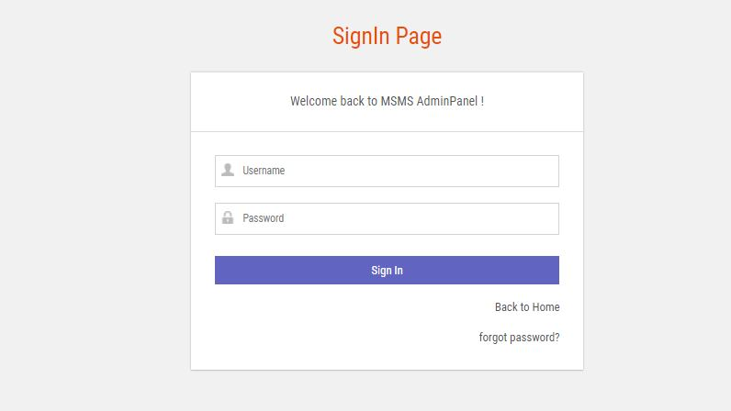

Figure 4.2: Login page interface

Book appointment interface

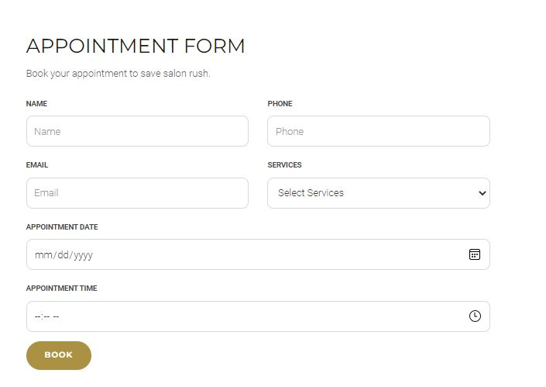

Figure 4.3: Book appointment interface

Add Customer interface

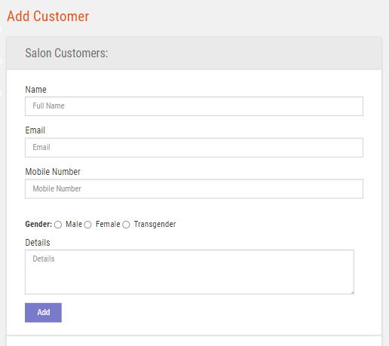

Figure 4.4: Add Customer profile

Services interface

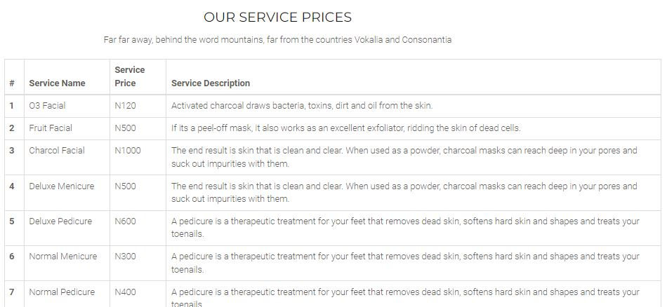

Figure 4.5: Services interface

Appointments interface

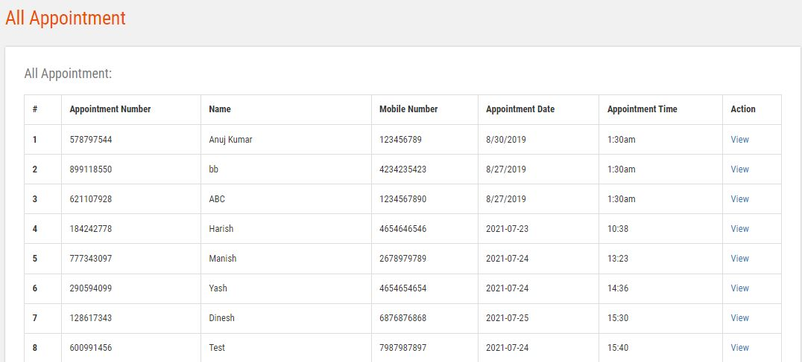

Figure 4.6: Appointments interface

Add service interface

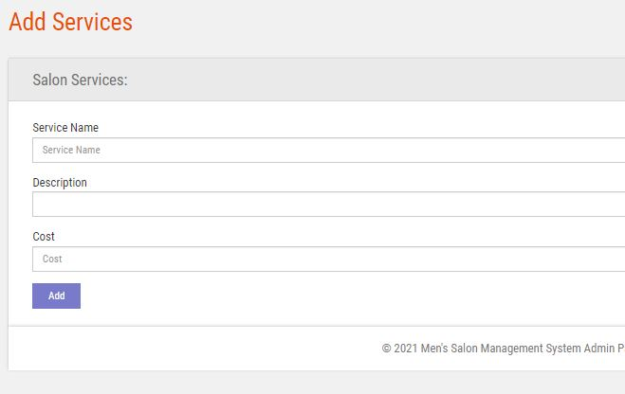

Figure 4.7: Add service interface

## 4.3 Discussion

**Welcome interface**

This is the first interface that the user will see, it contains the project topic, student and the supervisor of the project.

**Booking appointment page**

This section is used by the customer to book an appointment.

**Add service**

This section is used by the admin to add services that the saloon offer to her customers.

**Login interface**

This section is used by an existing admin to login into the system before completing any operation.

**Add Customer interface**

This section is used by the admin to add customers to the system

**Services interface**

This section displays all the services that the saloon offers to the customers.

**Appointments interface**

This section displays all the appointments to the admin.

**Add service interface**

This section is used to add services to the system.

## 4.4 User manual

The following are the necessary steps to take in order to use the system efficiently and effectively.

1. Load the url of the system <https://localhost/saloon/> the welcome page will be displayed.
2. Click on the **Proceed** button to proceed to the main system.
3. If you created an account, provide your login details by entering your username and password.
4. Depending on the login details provided you will be automatically directed to the dashboard.
5. The various task that you can perform on the portal will be displayed on the sidebar of the dashboard.

# CHAPTER FIVE

# SUMMARY, CONCLUSION AND RECOMMENDATION

## 5.1 Summary

The new system was designed in such a way that records and bookings of the saloon will be stored in a database for easy retrieval and manipulation of data that can be accessible from any place reducing the overcrowding and easy retrieval of the customers in the shop waiting to be attended to.

## 5.2 Conclusion

The interactive online platform for student and project supervisor was designed and implemented, the aim and specific objectives of the project were achieved successfully.

## 5.3 Recommendations

The researcher puts forward the following recommendations:

1. The saloon management should imbibe the use of this technology in carrying out her tasks in order to reduce the time wastage that is involved with the manual system.
2. The researcher also recommends that the system be put to effective use in order to derive the necessary efficiency of the system.

## 5.4 Contribution to knowledge

The new system was designed in a structured and robust way employing responsive design to it to ensure usability and efficiency. The project research will serve as a reference point for other research work and contribute immensely to knowledge for those conducting a research on similar topic.

## 5.5 Area for further work

The research work limited to saloon booking and management only. Therefore, the researcher suggests that further studies be conducted to include other functionalities such as web payment.

# REFERENCES

Babie, I. (2014). *Discovering Computers*: A Gateway to Information, Web Enhanced Complete. Thomson Course Technology. USA

Boye, R. (2015). *About Web Portals*: A home page doth not make a portal. Jossey-Bass, A Wiley Company.

Brayand, M. (2014). Portals in higher education. *Educause Journal Review, 35(4).*

Denning, L. (2017). Portals in higher education. *Educause Journal Review, 35(4).*

Ellis, K. (2011). *Design and implementation of Crisis and Emergency Reporting and Response system using SMS.* Addis Ababa University Digital Library L. Naismith, P. Lonsdale,

Florida, S. (2010). Online Admission System for School. Retrieved November 14, 2020 from <http://www.iseing.org/emcis/EMCIS2005/pdfs/22.pdf>

Hampton, R. (2012). *About Web Portals*: A home page doth not make a portal. Jossey-Bass, A Wiley Company

Henver, H. (2014). Tech Talk Event CNI Spring Task Force Meeting. Retrieved February 27, 2020 from [www.cren.net/know/techtalk/events/portals.html](http://www.cren.net/know/techtalk/events/portals.html)

Hint, N., Irelan, K. & Hoskisson, K. (2013). Exploring user perception of wireless. *Campus International Journal of Mobile Communications. Volume 5,(6),* 710- 730.

James, L. (2012). Portals in higher education. *Educause Journal Review, 35(4).*

Kassim, G. (2011). *Using Technology to make a step in business efficiency and responsiveness*. Regional Support Centres, London.

Kemoni, J. & Ngullube, J. (2018). *Mega-Universities and Knowledge Media –Technology Strategies for Higher Education*. Kogan Page: London.

Leykun, P. (2012). Development of Online Project Registration and Management System. *Campus-Wide Journal of Information Systems, 24(5),* 342-354. doi:10.1108/10650740710835760

Makhura, A. (2015). Development of Online Project Registration and Management System. *Campus-Wide Journal of Information Systems, 24(5),* 342-354. doi:10.1108/10650740710835760.

Malone, O. & Crownston, I. (2014) The Personal Research Portal: *Web Driven Individual commitment with open access development, Knowledge Management for Development Journal, Amsterdam, 3 (1),* 35-48.

March, L. & Smith, H. (2015). *Development of Online Student Course Registration System*. Retrieved January 16, 2016 from [www.cren.net/know/techtalk/events/](http://www.cren.net/know/techtalk/events/portals.html)

Rao, K. (2013). Remaking the Academy: Twenty-First Century Challenges to Higher Education in the Age of Information. *Educause Journal Review 35(2).*

Reus, H. (2013) Tech Talk Event CNI Spring Task Force. Retrieved March 18, 2020 from [www.cren.net/know/techtalk/events/portals.html](http://www.cren.net/know/techtalk/events/portals.html)

Sampson*, M.* (2012). *Availability, accessibility and use of ICT in management of students ‘academic affairs in Makerere University*, Makerere University.

Simon, O. (2016). Optimising workflow in andrology: a new electronic patient record and database". *Asian Journal of Andrology.*

Smith, J. (2017). The use of electronic information services by students at Glasgow Caledonian University. *Emerald Group Publishing Limited. Vine, 34(3),* pp. 113-118.

Yonan, I. (2019). The Personal Research Portal: *Driven Individual commitment with open access development, Knowledge Management for Development Journal, 3(1),* 35-48.

# APPENDIX A

Welcome interface



Figure 4.1: Welcome interface

Login interface



Figure 4.2: Login page interface

Book appointment interface



Add Customer interface



Services interface



Appointments interface



Add service interface



# APPENDIX B

**PROGRAM CODE**

<!DOCTYPE html>

<html lang="en">

  <head>

    <meta charset="utf-8">

    <meta name="viewport" content="width=device-width, initial-scale=1, shrink-to-fit=no">

    <meta name="description" content="">

    <meta name="author" content="">

    <title>Men Saloon Management System</title>

    <!-- Bootstrap Core CSS -->

    <link href="vendor/bootstrap/css/bootstrap.min.css" rel="stylesheet">

    <!-- Custom Fonts -->

    <link href="vendor/font-awesome/css/font-awesome.min.css" rel="stylesheet" type="text/css">

    <link href="https://fonts.googleapis.com/css?family=Source+Sans+Pro:300,400,700,300italic,400italic,700italic" rel="stylesheet" type="text/css">

    <link href="vendor/simple-line-icons/css/simple-line-icons.css" rel="stylesheet">

    <!-- Custom CSS -->

    <link href="css/stylish-portfolio.min.css" rel="stylesheet">

  </head>

  <body id="page-top" style="background:rgb(252, 144, 4);">

    <!-- Navigation -->

    <a class="menu-toggle rounded" href="#">

      <i class="fa fa-bars"></i>

    </a>

    <nav id="sidebar-wrapper">

      <ul class="sidebar-nav">

        <li class="sidebar-brand">

          <a class="js-scroll-trigger" href="#page-top">MEN SALOON MANAGEMENT SYSTEM</a>

        </li>

        <li class="sidebar-nav-item">

          <a class="js-scroll-trigger" href="msms/">Proceed</a>

        </li>

    </nav>

    <!-- Header -->

    <header class="masthead d-flex">

      <div class="container text-center my-auto">

        <h1 class="mb-1" style="font-family: 'Times New Roman', Times, serif; font-size: 30px; text-transform: uppercase;"><span style=" font-size: 30px; margin-top: 25px;"> DESIGN AND IMPLEMENTATION OF MEN SALOON MANAGEMENT AND BOOKING SYSTEM</span> <br><br><br>  </h1>

        <h3>BY: <br> ST/CS/ND/19/192, ST/CS/ND/19/198, ST/CS/ND/19/213 </h3> <br> <br>

        <h3>SUPERVISED BY: <br>MRs. AARON CATHERINE

        </h3>

        <br><br><br>

        <strong><a class="btn btn-primary btn-xl js-scroll-trigger" href="msms/" style="font-size: 20px;"><span class="fa fa-long-arrow-right"></span> PROCEED</a></strong>

              </div>

      <div class="overlay"></div>

    </header>

    <!-- Scroll to Top Button-->

    <a class="scroll-to-top rounded js-scroll-trigger" href="#page-top">

      <i class="fa fa-angle-up"></i>

    </a>

    <!-- Bootstrap core JavaScript -->

    <script src="vendor/jquery/jquery.min.js"></script>

    <script src="vendor/bootstrap/js/bootstrap.bundle.min.js"></script>

    <!-- Plugin JavaScript -->

    <script src="vendor/jquery-easing/jquery.easing.min.js"></script>

    <!-- Custom scripts for this template -->

    <script src="js/stylish-portfolio.min.js"></script>

  </body>

</html>

<?php

session_start();

error_reporting(0);

include('includes/dbconnection.php');

  ?>

<!DOCTYPE html>

<html lang="en">

<head>

    <title>Men Salon Management System || Service List</title>

    <!-- Bootstrap -->

    <link href="css/bootstrap.min.css" rel="stylesheet">

    <!-- Google Fonts -->

    <link href="https://fonts.googleapis.com/css?family=Roboto:300,300i,400,400i,500,500i,700,700i%7cMontserrat:300,300i,400,400i,500,500i,600,600i,700,700i" rel="stylesheet">

    <!-- Font Awesome -->

    <link href="css/font-awesome.min.css" rel="stylesheet">

    <!-- Style -->

    <link href="css/style.css" rel="stylesheet">

    <!-- HTML5 shim and Respond.js for IE8 support of HTML5 elements and media queries -->

    <!-- WARNING: Respond.js doesn't work if you view the page via file:// -->

    <!--[if lt IE 9]>

      <script src="https://oss.maxcdn.com/html5shiv/3.7.3/html5shiv.min.js"></script>

      <script src="https://oss.maxcdn.com/respond/1.4.2/respond.min.js"></script>

    <![endif]-->

</head>

<body>

   <?php include_once('includes/header.php');?>

    <div class="page-header"><!-- page header -->

        <div class="container">

            <div class="row">

                <div class="col-lg-12 col-md-12 col-sm-12 col-xs-12">

                    <div class="page-caption">

                        <h2 class="page-title">Salon Service</h2>

                        <div class="page-breadcrumb">

                            <ol class="breadcrumb">

                                <li><a href="index.php">Home</a></li>

                                <li class="active">service list</li>

                            </ol>

                        </div>

                    </div>

                </div>

            </div>

        </div>

    </div><!-- /.page header -->

    <div class="content">

        <div class="container">

            <div class="row">

                <div class="col-md-10 heading-section text-center ftco-animate" style="padding-bottom: 20px;">

            <h2 class="mb-4">Our Service Prices</h2>

            <p>Far far away, behind the word mountains, far from the countries Vokalia and Consonantia</p>

          </div>

               <table class="table table-bordered"> <thead> <tr> <th>#</th> <th>Service Name</th> <th>Service Price</th> <th>Service Description</th> </tr> </thead> <tbody>

<?php

$ret=mysqli_query($con,"select *from  tblservices");

$cnt=1;

while ($row=mysqli_fetch_array($ret)) {

?>

             <tr> <th scope="row"><?php echo $cnt;?></th> <td><?php  echo $row['ServiceName'];?></td> <td>N<?php  echo $row['Cost'];?></td> <td><?php  echo $row['Description'];?></td> </tr>   <?php

$cnt=$cnt+1;

}?></tbody> </table>

            </div>

        </div>

    </div>

    <div class="space-small bg-primary">

        <!-- call to action -->

        <div class="container">

            <div class="row">

                <div class="col-lg-8 col-sm-7 col-md-8 col-xs-12">

                    <h1 class="cta-title">Book your online appointment</h1>

                    <p class="cta-text"> Call to action button for booking appointment.</p>

                </div>

                <div class="col-lg-4 col-sm-5 col-md-4 col-xs-12">

                    <a href="appointment.php" class="btn btn-white btn-lg mt20">Book Appointment</a>

                </div>

            </div>

        </div>

    </div>

    <?php include_once('includes/footer.php');?>

    <!-- /.footer-->

    <!-- jQuery (necessary for Bootstrap's JavaScript plugins) -->

    <script src="js/jquery.min.js"></script>

    <!-- Include all compiled plugins (below), or include individual files as needed -->

    <script src="js/bootstrap.min.js"></script>

    <script src="js/menumaker.js"></script>

    <script src="js/jquery.sticky.js"></script>

    <script src="js/sticky-header.js"></script>

</body>

</html>